**KWAME NKRUMAH UNIVERSITY OF SCIENCE AND TECHNOLOGY,**

**KUMASI**



**COLLEGE OF ENGINEERING**

**DEPARTMENT OF COMPUTER ENGINEERING**

DESIGN OF A FACIAL RECOGNITION PAYMENT SYSTEM

Project submitted in partial fulfilment for a Degree of Bachelor Science (BSc.) in Computer

Engineering.

By

Owusu William Kwadwo

Nnuro Steven Kofi

Osei-Tutu Gideon

SUPERVISOR: ING. DR. ELIEL KEELSON

DECEMBER 2019

# DECLARATION

We hereby declare that except for specific references which have been properly acknowledged, this work is the result of our research and it has not been submitted in part or in whole for any other degree elsewhere.

Signature............................................................Date..................................................................

Owusu William Kwadwo (Candidate)

Signature............................................................Date..................................................................

Nnuro Steven Kofi (Candidate)

Signature............................................................Date..................................................................

Osei-Tutu Gideon (Candidate)

Signature............................................................Date..................................................................

Dr. Eliel Keelson (Supervisor)

# ABSTRACT

The rapid rise of the internet brought with it many advancements and advantages. Communicating with people all around the world, research work, online banking and online shopping (transactions) are a few of the advancements that the internet has gifted us.

Each of these advancements are not without its disadvantages though, and in the field of online transactions a lot of fraudulent activities involving transactions have popped up over the years. A wide array of security methods has been put in place to curtail these activities but perpetrators have still found ways to bypass all these measures.

Standard measures such as four or six digit pins, alphanumeric passwords, retina scan and fingerprints have been implemented to secure online transactions. These features are good in their own respect but are not secure enough to prevent hackers and perpetrators from getting access to a user’s account and performing unauthorized transactions.

Take for example, a user who forgets her password often so decides to write it down on a piece of paper and stores it somewhere she feels is safe from prying eyes. In the eventuality of anyone stumbling across it, it becomes very easy to access her account and perform transactions without her knowledge. A user who also regularly loses her credit card could be a victim of such fraudulent transactions.

This calls for a better and efficient method of keeping one’s account, personal information and transactions safe from attackers. We therefore decided through extensive research that the best way to do this would be through implementing a front-view facial recognition system as the security method to perform online transactions.

This project is therefore aimed at developing a facial recognition system which is the most efficient and suitable biometric technology to secure payments, transactions and also address the aforementioned challenges and disadvantages of the other security measures. With the facial recognition system users will feel safe, secure and have the peace of mind knowing that no one has access to their accounts and their online transactions can be handled with speed, convenience, precision and security.

# DEDICATION

We dedicate this project to our supervisor, Ing. Dr. Eliel Keelson, for the aid, training and knowledge imparted to us during our stay in this noble institution and for the efforts contributed towards the completion of this project. May God richly bless him and grant him with more wisdom and insight.

# ACKNOWLEDGEMENT

Without God this project will not have been possible, we therefore acknowledge His grace that was assured us from the commencement to the final phase of this project.

We also extend our warmest gratitude to our supervisor, Ing Dr. Eliel Keelson, for his contribution, supervision and insightful evaluations in making this process a success.

Table of Contents

DECLARATION 3

ABSTRACT 4

DEDICATION 5

ACKNOWLEDGEMENT 6

LIST OF FIGURES 9

LIST OF TABLES 10

LIST OF ABBREVIATIONS 11

1 CHAPTER ONE: INTRODUCTION 12

1.1 BACKGROUND OF THE STUDY 12

1.2 PROBLEM STATEMENT 14

1.3 RESEARCH OBJECTIVES 17

1.3.1 General Objectives 17

1.3.2 Specific Objectives: 17

1.4 SIGNIFICANCE OF THE STUDY 17

1.5 ORGANIZATION OF STUDY 18

2 CHAPTER TWO: LITERATURE REVIEW 19

2.1 INTRODUCTION 19

2.1 REVIEW OF RELATED WORKS 19

2.1.1 FACIAL RECOGNITION TECHNOLOGY IN CHINA 20

2.1.2 Facial Recognition Technology in Anti-Spoofing Attacks 21

2.1.3 A SHORT STUDY ON FACIAL RECOGNITION AND ITS ALGORITHMS 23

References 37

# LIST OF FIGURES

Figure 2.1 Facial recognition system framework as suggested by Shang-Hung Lin (24) 22

Figure 2.2 Face Detection and Recognition Flow Diagram 23

Figure 2.3 Taken from detecting faces in images: A Survey [29] 24

Figure 2.4 Showing PR curve on AFW [33] 30

Figure 2.5 Face detection classified into different methodologies [30] 31

Figure 2.6 Various face detection methodologies [34] 32

Figure 2.7 Face Detection in Dark and Colored Men by [35] 33

# LIST OF TABLES

Table 2.1 showing standard database test set for Face Detection. Yang et al. [29]. 25

Table 2.2 Results of two image test sets experimented Yang et al[29] 26

Table 2.3 Results showing exhaustive full scanning method and proposed scanning method. Ryu et al 27

Table 2.4 Performance Comparison by different researchers and proposed system by [31] 28

Table 2.5 Showing results of Sussex face database[32] 28

Table 2.6 Showing results of CMU Test Set A [32] 29

Table 2.7 Various detection rates by different algorithms showing positive and false detection rates [37] 33

Table 2.8 Detection accuracy system by Wang et al (2015, p.331) 33

Table 2.9 Comparing Different Algorithms on classification rates [38] 34

Table 2.10 Comparison of results by Different Researchers showing face detection accuracy and false detection 35

# LIST OF ABBREVIATIONS

**Abbreviation Meaning**

CNN Convolutional Neural Networks

CCTV Closed-Circuit Television

2D 2 Dimensional

PIN Personal Identification Number

FRT Facial Recognition Technology

KFC Kentucky Fried Chicken

LBP Local Binary Pattern

MIT Massachusetts Institute of Technology

CMU Central Michigan University

SNoW Sparse Network of Windows

AT&T American Telephone & Telegraph

BioID Biometric Identification

FERET Facial Recognition Technology

CGM Constrained Generative Model

GM Generative Model

SWN Shared Weights of Network

AFLW Annotated Facial Landmarks in The Wild

AFW Annotated Faces in The Wild

FDDB Face Detection Data Set

OpenCV Open Computer Vision

PDMS Point Distribution Models

SVM Support Vector Machine

PCA Principal Component Analysis

FGPA Field Gate Programmable Array

ANN Artificial Neural Networks

# 1 CHAPTER ONE: INTRODUCTION

### 1.1 BACKGROUND OF THE STUDY

A facial recognition system is one that has the capability of identifying or verifying the identity of a person using their face. It captures, analyzes and compare patterns based on the person’s facial details [1].

Ecommerce, also known as electronic commerce or internet commerce, refers to the buying and selling of goods and services using the internet, and transfer of money and data to execute these transactions. Ecommerce is often used to refer to the sale of physical products online, but it can also describe any kind of transaction that is facilitated through the internet [2].

Most people confuse e-business with ecommerce but the clear distinction is in e-business referring to all aspects of operating an online business, ecommerce refers specifically to the transaction of goods and services [2].

Considering the aspect of facial recognition, humans have been able to identify and differentiate between familiar faces and that of strangers for centuries. In recent years humans have applied that ability to technology and implemented it in artificial intelligence creating applications that use facial recognition. The easiest explanation of this technology is that it uses a “camera to pinpoint facial features and create a map of the person’s face. The data gathered can then be analyzed against prerecorded facial images in a database to identify the person in question” [3].

This technology could use various distinct features such as the length between the pupils, the breadth of the nose and the distance between two points on the jawline. The software has evolved to the point where it can perform this under two seconds [3].

The main question is how did we get to this point? The origin of facial recognition can be traced back to the first camera that was invented. The pioneer of facial recognition can be traced back to Woodrow Wilson Bledsoe who was invested in the field of artificial intelligence and pattern recognition technology. Along with his team he undertook projects in Palo Alto, California in the mid-1960s [4].

He along with the team created a device that used a stylus and a tablet to physically record facial features. The results of his innovation and study brought about the creation of Eigenfaces. Eigenfaces are in simple terms 2D facial structures generated by using algebraic methods. This was the prime breakthrough in computerized facial recognition [5].

Considering ecommerce, its applications are endless. It could be used for a myriad of activities in almost all facets of the internet. Some of its uses relate to the banking, educational, publishing, retailing and marketing. Our main focus is on the retail side of ecommerce. The world has quickly adjusted itself to the advantages the internet provides and has guided itself into utilizing the retailing aspect of ecommerce.

The ease of use is one of the main reasons the current generation of internet users have bought into this idea. With a simple click of a button you could purchase any item at any location in the world and have it delivered to your doorstep. The comfort associated with this is what has pulled many users to patronize these services.

Back to facial recognition, which is our primary motivation for the security of ecommerce transactions. We are met with the methods involved in procuring the faces. Most of these methods could be summed up into a simple algorithm involving two steps. Feature extraction is the initial step that is taken with the next being classification of objects [6].

Many algorithms have materialized making facial recognition easier and faster. These algorithms could be divided into two primary factions, the first being geometric which basically picks out distinguishing features and photometric which is also a statistical approach that extracts the image and condenses it into values and juxtaposes them with a variety of models to eliminate discrepancies.

Other algorithms that have also cropped up in recent times are the gradient: which replaces every pixel representation of how bright that pixel is compared to those around it making it easier to recognize the same face regardless of lighting conditions and projection: which takes a 2D image and casts it around a 3D object preferably a cylinder. This method is able to bring out special features that were difficult to notice [7].

With regards to ecommerce it will afford users the opportunity to simply pay using their face with a camera pointed at it. This will curb most of the problems associated with forgetting passwords and mixing them up with other password used to log in to other applications. Where problems have arisen with customers’ PINs and card numbers being divulged, the facial recognition technology is essential in adding an extra layer of security. Fraud involving users having their account wiped out via fraudsters using the money to purchase items online will also be limited. Users could be rest assured that without their face present, transactions and data pertaining to their account will be safe and protected.

### 1.2 PROBLEM STATEMENT

Every ecommerce platform’s most important feature is security. Security has evolved over the years and we are always trying to find better ways to secure these platforms. We have evolved from pin codes to biometric security features like fingerprints, iris scanning and facial recognition.

All of these methods are available but there are still cases of fraud, hacking and accounts on ecommerce platforms being compromised. Perchance by a strange quirk there have been developments in recent years to use biometric security features in securing transactions. A recent example could be referred to where Alipay, the financial arm of Alibaba has introduced an upgrade over their “Smile-to-pay”. This uses a device roughly the size of an iPad to verify transactions for payment. It uses facial recognition, one of the biometric security options that has the potential to become the leading security option for all platforms with a push from major mobile payment players [8].

With reference to using facial recognition to verify payments, it serves as one of the most secure forms of security as compared to PIN codes. Using a four-digit PIN code there are 10,000 possible variations. A six-digit pin code has 10,000,000 possible variations [9]. This means that the longer the number of digits the harder it is to guess. Therein lies the problem of finding a very long PIN code to deter attackers. But a longer code brings with it the issue of remembering what it is. This is what we aim to control by using facial recognition.

A digital camera is a device that captures photographs in digital memory [10]. This could be a camera phone, webcam or a dedicated device to capture images or videos.

The photograph could be examined on a mobile phone, a computer or any connected display. It could even be transferred via telephone line or a network. The processing of the still images or video captured is done by the software backing the hardware.

Cameras have always had the ability to capture people and the scenes around them but has always found it grim trying to classify or categorize people unless it has been stored in a locally or already stored in a database.

Saving passwords and email addresses to make transactions can also prove an arduous task for humans especially if they are signed up t many services and have a variety of passwords to cater for all of them. It is prudent to have different passwords for each service as it will make it more difficult for attackers to gain access to the accounts.

Perusing a circumstance where a user has multiple accounts on different ecommerce platforms. It is expedient to have a simple way of authorizing transactions. A technology with the ability to easily recognize a face and match it to the user’s credentials is one of the premier solutions to curb all the hitches and disadvantages associated with having manifold passwords. This will eliminate the human error factor introduced in trying to find methods to remember them. It also a smoother and simpler authorization process as all one needs is a camera and a software to process the image.

Big data, referred to by the conventional software tools in a certain range of time capture, management and processing of data, is the need for new processing mode to have a stronger decision-making ability, insight discovery and process optimization capabilities of massive, high rates of growth and diversification of information assets [11].

A lot of governments and institutions are funding research works as to how to manage and analyze the data captured from the camera and the images fed into the system more efficiently. One of the budding technologies that contributes to this section of facial recognition is deep learning.

With this technology there are so many amazing benefits and possibilities, it means that large sets of data pertaining to images of people could be fed into the system and the features necessary to identify the user and grant the anticipated output.

Humans are prone to errors and instead of certifying and allowing access to the ecommerce platforms via PINs, passwords, plastic cards, tokens, keys and so on, a biometric verification technology involving facial recognition technology is key. Passwords and PINs are difficult to remember and guess, cards and tokens can also be misplaced, replicated or stolen. By integrating our ecommerce platform with this security feature, the handling and authorization of transactions will be made easier and efficient and that is the focus of this project.

### 1.3 RESEARCH OBJECTIVES

### 1.3.1 General Objectives

This project is aimed at creating an ecommerce application and developing a payment gateway with facial recognition system using the classical approach, which is frontal or front view recognition.

## 1.3.2 Specific Objectives:

1. To develop an ecommerce web and mobile application.
2. To train the model with a catalog of human faces using TensorFlow for facial recognition.
3. To develop a safe and secure checkout system using facial recognition.

### 1.4 SIGNIFICANCE OF THE STUDY

The primary goal of this project is for the authorization and verification of transactions on an ecommerce platform using facial recognition technology: a camera to scan the front view of a user’s face and compared to the faces in the database is sufficient to recognize the individual.

The system will be able to grant access to the user of the account whose face was scanned.

Illustrating an occurrence where one needs to purchase an item from selected items obtained via the ecommerce platform, the person would only need to place the front view of the face in front of the camera and just wait for verification from the system to approve the checkout.

There are a few implementations in china where facial recognition technology has been implemented in ecommerce platforms and their security systems [8]. As at the time of writing this report there is no ecommerce platform integrated with facial recognition technology in Ghana.

This project is important for security’s sake as it may aid in the checkout process on ecommerce platforms with much more efficiency and precision to improve operational performance of the platform.

### 1.5 ORGANIZATION OF STUDY

The outline of the subsequent chapters would be as outlined:

Chapter two will discourse prevailing works on previously employed facial recognition algorithms and systems with the purpose of recognizing their setbacks and how they can be enhanced.

In chapter three we would elucidate the study procedure designated for the design of the suggested facial recognition system.

Chapter four will discuss outcomes of the testing and evaluation of the complete design of a facial recognition system integrated with the ecommerce platform would be presented.

Chapter five would abridge and finalize the study, itemize the challenges faced in the course of research in addition to recommendations.

## 2 CHAPTER TWO: LITERATURE REVIEW

### 2.1 INTRODUCTION

In this chapter, an in-depth discussion on the current strides reached in the world of facial recognition systems would be made. A discussion of existing literature on already implemented facial recognition systems would also be presented with much emphasis on their strengths and weaknesses. This chapter will also touch on the general disadvantages of a facial recognition system, which clearly are privacy issues. This chapter will also consider the technologies that an efficient facial recognition system is built on.

Chapter 2.1 will in this chapter, a brief overview of studies made on face detection and recognition will be introduced alongside some popular face detection and face recognition algorithms. This will give a general idea of the history of systems and approached that have been used so far.

Chapter 2.2 will highlight on Deep Learning and its algorithms, which is basically the baseline

technology for biometric systems such as facial recognition and detection systems.

In Chapter 2.3, will present a summary of this chapter, in addition to evaluation of the pros and cons of the reviewed works.

### 2.1 REVIEW OF RELATED WORKS

Recognition software, coupled with machine learning, is now sophisticated enough to distinguish between objects within images, as well between faces [12].

On the benefits of facial recognition technology, it can be used to prevent identity fraud. Incorporating facial recognition software into existing systems has now become normal in the sense that people and companies are now using it for access into their buildings and offices, to monitor attendance and unlocking of their phones.

### 2.1.1 FACIAL RECOGNITION TECHNOLOGY IN CHINA

China is one country that has made a broad headway into the advancement, execution and practice of facial recognition technology. Some of the advances of FRT in China are as follows: In the area of public safety, facial recognition technology has been widely used in surveillance systems, tracking criminals and identifying fugitives.[13] With the introduction of various new security concepts in China, all walks of life have started to establish CCTV system or alarm system[18]. Especially in banking, communications, postal savings, electricity, Internet cafes and other places, we have established a networked alarm system, which has played a major role in preventing and preventing crime and maintaining social stability.[19] In this study, Disney theme park in mainland China is taken as the object to apply the new technique in the security management. It is located in the new town of Changsha, pudding new area, Shanghai. Which officially opened on June 16, 2016.It is the first in mainland China, the third in Asia, and the sixth Disney theme park in the world. There are seven theme parks in the park: mickey street, fancy garden, adventure island, treasure bay, tomorrow world, dream world, toy mobile garden. There are also two theme hotels: Shanghai Disneyland hotel, toy story hotel and a subway station; Disney station. There are many global launch rides. Shanghai Disneyland is expected to receive more than 50 million visitors each year. Now, with the popularization of computer and application, network communication technology and the rapid development of image compression processing technology, and combined with the latest biometric identification technology, can provide more security for Disneyland, advanced high-tech security solutions. Xinjiang, China’s restive far northwestern region with a population that is 50 per cent Uighurs (Turkic-speaking Muslims), is the proving ground for China’s expanding surveillance system. Surveillance equipment, checkpoints and human informants are ubiquitous and inevitable parts of quotidian life there, especially if you’re a Uighur or a Kazakh. Xinjiang is becoming “a real-life laboratory for surveillance” involving FRT, smartphone scanners, voice analysis and compulsory GPS tracking devices for all vehicles. Surveillance capabilities perfected here are then implemented in other parts of China. It has also been used to fight human trafficking, detect kidnappers, and help to trace long-missing children for family reunion [14]. In business and finance, facial recognition is becoming a more and more popular choice in payment and courier services, and helps to maximize security and minimize fraud.[15] On September 1, 2017, Alipay rolls out world’s first ‘Smile to Pay’ facial recognition system at KFC restaurant outlet in Hangzhou successfully used FRT to pay for meals that are being bought at the restaurant without the use of physical cash or credit card[21]; also, in an agreed upon experiment has extended its “Smile-to-Pay” facial recognition payment system to more than 300 KFC locations across the country, as it continues to roll out digital technologies to improve customer experiences, growth, and operational efficiency.[22] In transportation, facial recognition has been deployed in airports and train stations to save travelers time from checking in, help travelers to pay for their fares, and identify unlicensed drivers and jaywalkers.[16]

From the ticket turnstiles at the train station,[17] to getting through customs and even buying a duty-free bottle of wine, facial recognition scanners are everywhere at the city’s newest airfield: the sprawling, starfish-shaped Beijing Daxing International Airport. The technology, which links a passenger’s face to their passport at check in, will speed up the whole process of moving through the airport, according to Wang Qiang, the deputy general manager of planning and design.[23]

### 2.1.2 Facial Recognition Technology in Anti-Spoofing Attacks

Face recognition systems have become a major target of spooﬁng attacks. In such scenarios, an impostor attempts to be granted in an identiﬁcation process by forging someone else’s identity. As procedures to replicate human faces are very much standard nowadays (e.g. Photo and 3D printing), spooﬁng detection has become mandatory in any suitable face recognition system. Several approaches for spooﬁng detection have been developed in the last decade. Recently, two main surveys on the subject present a comprehensive review.[ 27, 28] in [27], a survey on anti-spooﬁng methods focuses not only on face, but also on other biometric traits (e.g., iris, voice, ﬁngerprint); in [28], face anti-spooﬁng methods are discussed by considering the intrusiveness of each method, with few attention on comparative analysis and temporal evolution of the ﬁeld. On the other hand, the proposed survey focuses only on face-oriented works, reviewing and analyzing the most relevant works on face spooﬁng detection in the literature towards depicting the advance of the detection methods in the last decade. An extensive set of face anti-spooﬁng methods is presented, also depicting the evolution of the existing works.

In this section we review the prior face anti-spoofing approaches in four groups: live- ness methods, existing multi-cues approaches, and applying of Convolutional Neural Networks (CNN) for face anti-spoofing. The liveness detection approach aims at detecting vital signs through analyzing human face motion. The reason why motion analysis is a good spoofing countermeasure is that the movement characteristics of rigid planar objects, like photo prints or tablet display, differs significantly from that of real human faces which are complex non-rigid 3D objects. The most common temporal cues used for liveness detection are facial expression alterations [29], Instead of analyzing specific face parts, some approaches use more general motion features and techniques, like optical ﬂow analysis [30], Euler motion magnification [31], local speed patterns [32], Shearlet-based features [33] and recurrent neural networks [34]. Motion-based methods are usually effective to printing and photo replay attacks, but become powerless under video replay attacks and printing attacks with cut out eyes or lips area. The multi-cues method that integrate evidence from multiple complementary sources. The idea behind such approach is that anti-spoofing features relying on a single cue can be not effective for all kinds of presentation attacks, while combining cues of different nature can result in more robust anti-spoofing system. So, in [34] and [35] authors proposed to combine some texture features (color histograms, Gabor features, LBP, etc.) with motion analysis (local face motion, correlation between the face and background regions), and fuse results at a score level. Convolutional Neural Networks have proven to be effective in a wide range of computer vision problems. As for facial analysis, modern deep learning approaches consistently outperform other learning paradigms in the tasks of face detection and face recognition. However, in the face anti-spoofing area, the use of deep convolutional networks is still not so common, and has not been sufficiently investigated. Most of the existing CNN-based approaches rely on the assumption of existing discriminative texture patterns for live and spoof examples, and try to automatically compose a model for extraction of such features.

### 2.1.3 A SHORT STUDY ON FACIAL RECOGNITION AND ITS ALGORITHMS

Most face recognition systems rely on face recognition algorithms to complete the following functional task as suggested by Shang-Hung Lin. [36]

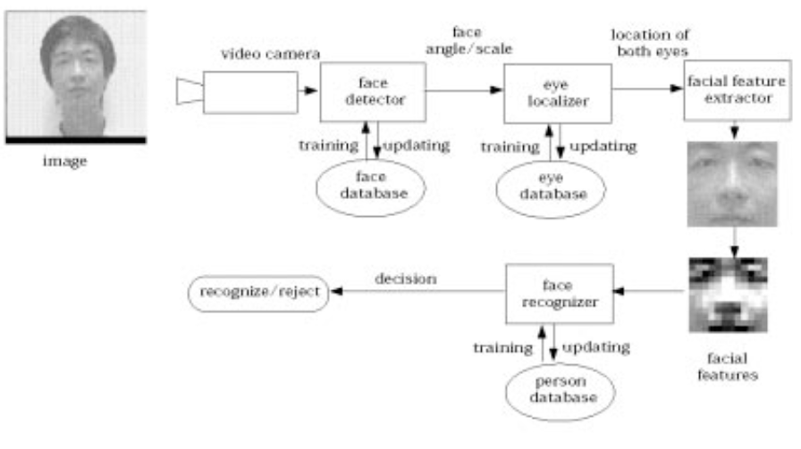

Figure 2.1 Facial recognition system framework as suggested by Shang-Hung Lin (24)

The figure below shows a simplified diagram from the framework for face recognition from the study suggested by Shang-Hung Lin. (24).

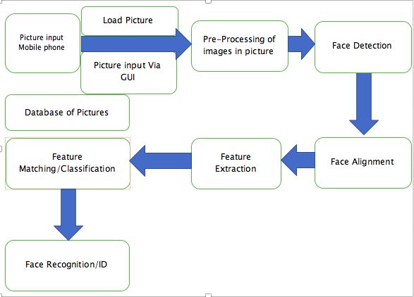

Figure 2.2 Face Detection and Recognition Flow Diagram

From the figure, above, **Face Detection** or face detector will detect any given face in the given image or input video. **Face localization**, will detect where the faces are located in the given image/video, by use of bounding boxes. **Face Alignment** is when the system will find a face and align landmarks such as nose, eyes, chin, mouth for feature extraction. Feature extraction, extracts key features such as the eyes, nose, mouth to undergo tracking. Feature matching and classification. matches a face based on a trained data set of pictures from a database of about 200 pictures. Face recognition, gives a positive or negative output of a recognized face based on feature matching and classification from a referenced facial image.

Face detection is the process of locating a face in a digital image by any special computer software build for this purpose. Feraud et al [37] discuss face detection as “To detect a face in an image means to find its position in the image plane and its size or scale “.

As figure 2.2 shows, the detection of a face in a digital image is a prerequisite to any further process in face recognition or any face processing software.

In early years, face detection algorithms focused mainly on the frontal part of the human face (Srinivasan, Golomb and Martinez, 2016, p.4434).

However, in recent years, Cynganek, (2013, p.346) suggest that newer algorithms take into consideration different perspectives for face detection. Researchers have used such systems but the most challenge that has been faced is to make a system detect faces irrespective of different illumination conditions. This is based on a study by [40] on the Yale database which contains higher resolution images of 165 frontal faces. Face detection is often classified into different methods. In order to face the first major problem of the project (Detecting students faces), a wide range of techniques have been researched. These several face detection techniques/ methodologies have been proposed by many different researchers and often classified in major categories of different approaches. In this paper, we will look at some reviews and major categories of classification by different groups of researchers and relate it to the system.

Yang et al (2002) classifies face detection methodologies into four major categories: Knowledge-based, Feature invariant, Template matching and appearance-based approaches. **Knowledge Based** Method that uses human knowledge or human coding to model facial feature based on nature of the human face such as two eyes, mouth and the nose. This is very easy to apply the rules but very difficult to detect in various background depending on the pose and illumination. Low detection accuracy with small burden of calculation and short detection time.

[41] In order to investigate this method created multiple resolution hierarchy of images by averaging and subsampling as on the figure 2.3 below.

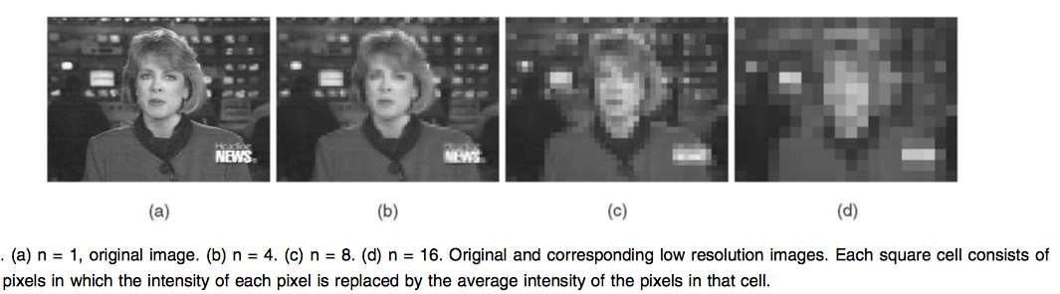

Figure 2.3 Taken from detecting faces in images: A Survey [41]

They subdivided these resolution hierarchies into three levels with level 1 being the lowest resolution which only searches for face candidate and further processed at finer resolutions. At level 2 they used the face candidate in level 1 to alongside local histogram equalization followed by edge detection. At level three, the surviving face candidate region uses a set rule responding to facial features such as mouth and eyes. They conducted their experiment on 60 images. Their system located faces on 50 of these images and 28 images gave false alarm, thus giving a success rate of 83.33% and a false alarm rate at 46.66%. **Feature-Based-Methods** that uses algorithms to look for structural features regardless of pose, viewpoint or lighting conditions to find faces. **Template Matching Methods;** uses standard facial patterns stored for use to correlate an input image with the stored pattern to compute for detection. Appearance Base Methods; uses a set of training sets of images to learn the templates and capture the representative of facial appearance. Furthermore, Yang et al. also carried out their experiments on a standard database set which is shown on the Table2.1 and Table 2.2 Yang et al. (2002, pp53-54) below with the detection rate results and false detection rates.

|  |  |  |
| --- | --- | --- |
| Data Set | Location | Description |
| MIT Test Set [514] | [http://www.cs.cmu.edu/`har](http://www.cs.cmu.edu/%60har) | Two sets of high- and low-resolution grayscale images with multiple faces in complex background |
| CMU Test Set [128] | [http://www.cs.cmu.edu/`har](http://www.cs.cmu.edu/%60har) | 130 grayscale images with a total of 507 frontal faces. |
| CMU Profile Face Test Set [141] | ftp://eyes.ius.cs.cmu.edu/usr20/ftp/testing_face_images.tar.gz | 208 grayscale images with faces in profile views. |
| Kodak Data Set [94] | Eastman Kodak Corporation | Faces of multiple size, pose and under varying illumination in color images. Designed for face detection and recognition. |

Table 2. showing standard database test set for Face Detection. Yang et al. [41].

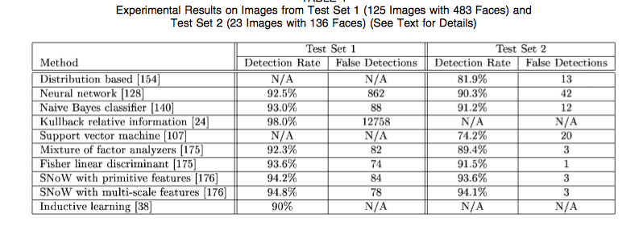

Table 2.2 Results of two image test sets experimented Yang et al [41]

As Table 2.2 summarizes, the experimental results show images of different training set with different parameters of tuning which has a direct impact on the training performance. For example, the dimensionality reduction is carried out to improve computation efficiency and detection efficacy, with image patterns projected to a lower dimensional space to form a discriminant function for classification. Also, the training and execution time and the number of scanning windows in these experimented influenced the performance in some way. Hjelmås and Low [42], classifies face detection methodologies into two major categories. Image-based approaches, which is further sub-categorized into Linear subspace methods, Neural networks and statistical approaches.

**Image Based Approaches**; Most of the recent feature-based attempts in the same study by [42] have improved the ability to cope with variations, but are still limited to head, shoulder and part of frontal faces. There is therefore need for techniques to cope in hostile scenarios such as detecting multiple faces in a cluttered scene, e.g. clutter-intensive background. Furthermore, this method ignores the basic knowledge of the face in general and uses face patterns from a given set of images. This is mostly known as the training stage in the detection method.

From this training stage, the system may be able to detect similar face patterns from an input image. A decision of face existence by the system is now established based on a comparison of the distance between the pattern from the input image and training image with a 2D intensity array extracted from the input image. Most image-based approaches use window-scanning techniques for face detection.

Window scanning algorithm searches for possible face locations at all scales. This method depends on window scanning algorithms. In other research carried out on this method which depends on window scanning algorithms, [43], in their study experimented the scanning window techniques discussed by [42] in their system. They go further to experiment their system, based on a combination of various classifiers for a more reliable result compared to a single classifier. They designed multiple face classifiers which can take different representations of face patterns. They used three classifiers, Gradient feature classifier which contains the integral information of pixel distribution that returns certain invariability among facial features. The second classifier is Texture Feature which extracts texture features by correlation (uses joint probability occurrence of specified pixel), variance (measures the amount of local variations in an image) and entropy (measures image disorder). The third classifier used here is Pixel Intensity Feature, which extracts pixel intensity features of the eye, nose and mouth region for determining the face pattern. They further used Coarse-To-Fine Classification approach with their classifications for computational efficiency. Based on 1056 images which were obtained from the AT&T, BioID, Stirling, and Yale dataset, they achieved the results presented in Table 2.3 and Table 2.4 [43] The first face classification of their experiment with respect to shift in both x and y direction achieved a detection rate of 80% when images are shifted within 10 pixels in the x direction and 4 pixels in the y direction. The second and third face of their classification showed a detection rate of over 80% when 2 pixels were shift in both x and y directions respectively.

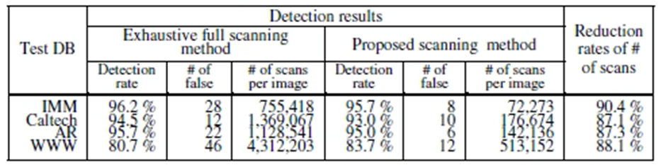

Table 2.3 Results showing exhaustive full scanning method and proposed scanning method. Ryu et al

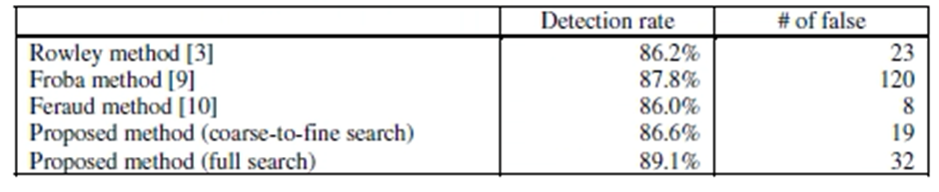

Table 2.4 Performance Comparison by different researchers and proposed system by [43]

As seen in Table 2.4, their system achieved a detection rate between 93.0% and 95.7%. Rowley et al. 1998 in their study on Neural Network-Based face detection, experimented on their system which applies a set of neural network-based filters to an image and then uses an arbitrator to combine the outputs. They tested their system against two databases of images. The CMU databased which was made of 130 images and the FERET database achieve a detection rate of 86.2% with 23 false detections. Feraud et al [44] also experimented on neural network-based face detection technique. They used a combination of different components in their system (motion filter, color filter, pre-network filter and large neural network). The pre-network filter is a single multilayer perceptron, with 300 inputs corresponding to the extracted sizes of the sub-windows, hidden with 20 neurons and outputs a face/nonface for a total of number of weights [reference]. These components, with a combination of neural network achieved an 86.0% detection rate with 8 false detections, based on a face database of 8000 images from Sussex Face Database and CMU Database which is further subdivided into different subsets of equal sizes corresponding to different views. (page 48). Table 2.5 and Table 2.6 [44] below shows the experimental results carried out by these researchers.

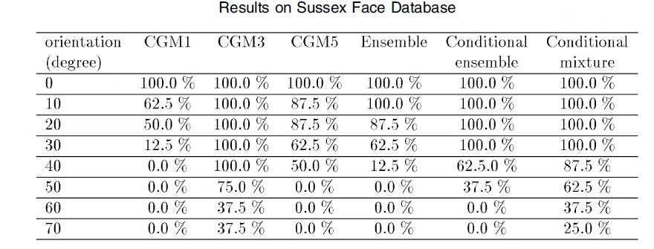

Table 2.5 Showing results of Sussex face database [44]

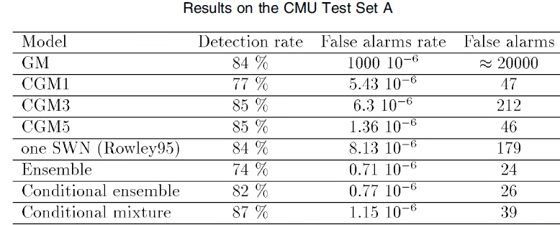

Table 2.6 Showing results of CMU Test Set A [44]

Wang et al. (2016) in their study to support neural network face detector used a multi-task convolutional neural network-based face detector, which relies directly on learning features from images instead of hand-crafted features. Hence their ability to differentiate faces from uncontrolled backgrounds or environments. The system the experimented on used the Region Proposed Network which generates the candidate proposal and the CNN-Based detector for the final detection output. They experimented this based on 183200 images from their database and used the AFLW dataset for validation. Their face detector system was evaluated on AFW, FDDB and Pascal faces datasets respectively and achieved a 98.1% face detection rate. The authors did not reveal all the facts leading to the development of the system and I have limited time to implement this on OpenCV. 2.8 [45], shows the different comparisons of their system against other state of the arts. [45], discuss their system (FaceHunter) perform better than all other structured models. However, this cannot be independently verified as this system was commercialized. One cannot conclude if this was for marketing purpose or a complete solution to the problem as I have limited time to implement it.

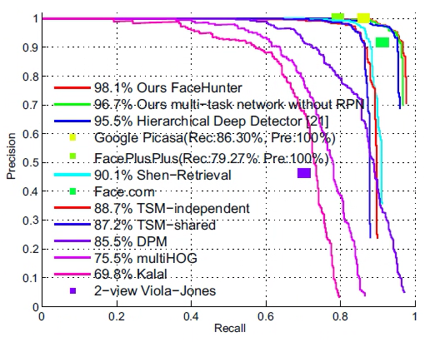

Figure 2. Showing PR curve on AFW [45]

The other major category is **Feature-based approaches;** depends on extracted features which are not affected by variations in lighting conditions and pose. This according to these researchers,[42] further clarifies that “visual features are organized into a more global concept of face and facial features using information of face geometry “. This technique in my own opinion will be slightly difficult to use for images containing facial features from uncontrolled background. This technique relies on feature analysis and feature derivation to gain the required knowledge about the face to be detected. The features extracted are the skin color, face shape, eyes, nose and mouth.

[42] Further placed the feature-based approach into sub categories of; Low level analysis (Edges, Gray-levels, Color, motion and generalized measure).

Feature analysis (Feature searching and constellation analysis).

Active shape models (Snakes, Deformable templates and Point distribution models (PDMS).

Figure 2.5 shows the different approaches for Face detection as reported in a study by Hjelmås and Low, (2001), which can be compared with Figure 2.6 showing the exact same classification by Modi and Macwan (2014, p.11108).

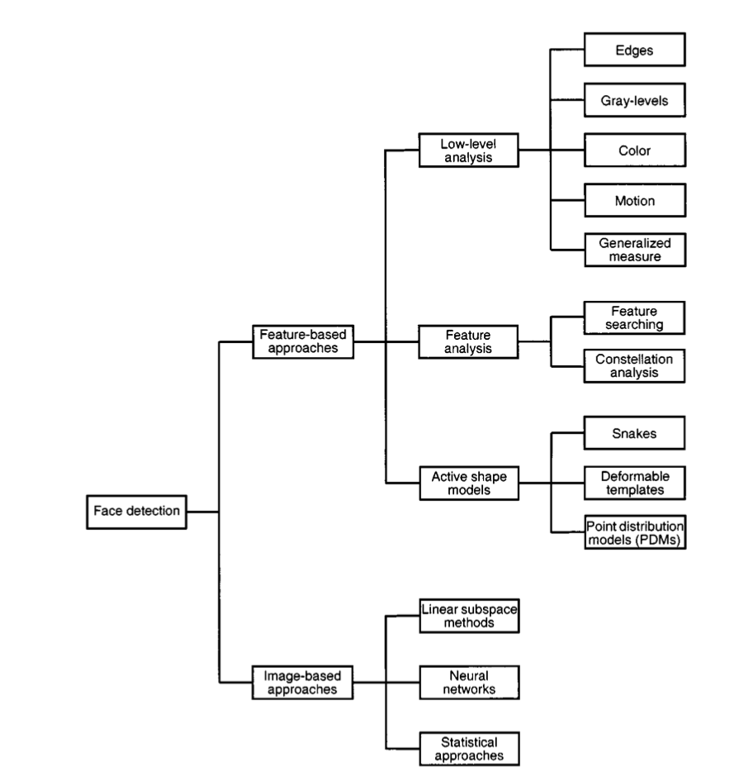

Figure 2. Face detection classified into different methodologies [42]

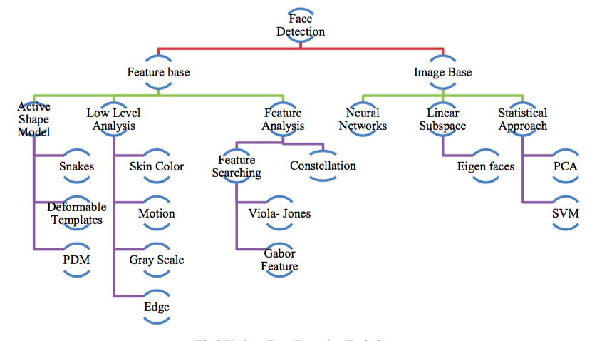

Figure 2.6 Various face detection methodologies [46]

[42] in their study, show experiment based on edge-detection based approach for face detection, on a set of 60 images of 9 faces, with complex backgrounds and correctly detected 76% of faces with an average of two false alarms per image.[47], in their study, experimented face detection based on the Viola-Jones algorithm in a dataset of dark and colored men to support their statement which states “It is possible to detect various parts of the human body based on the facial features present”, like the eyes, nose and mouth. In this case, systems as such will have to be trained properly to be able to distinguish features like the eyes, nose, mouth etc., when a live dataset is used. The Viola-Jones algorithm to detect faces as seen in the images in Figure 2.7 which shows dark and colored skin faces detected accurately.

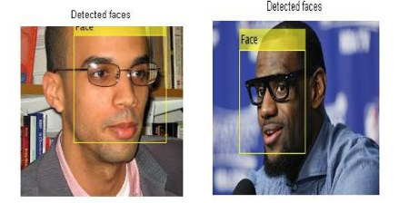

Figure 2.7 Face Detection in Dark and Colored Men by [47]

Also, in support of the claim made by [47] the research carried out by Viola-Jones to come up with the Viola-Jones algorithm in face detection, has had the most impact in the past decade. As suggested by [48], the Viola-Jones in face detection is widely used in genuine applications such as digital cameras and digital photo managing software. This claim is made based on a study by [49]. Table 2.6 gives a summary of the results obtained by these experts, showing various numbers of false and positive detections based on the MIT and CMU database set with 130 images and 507 faces.

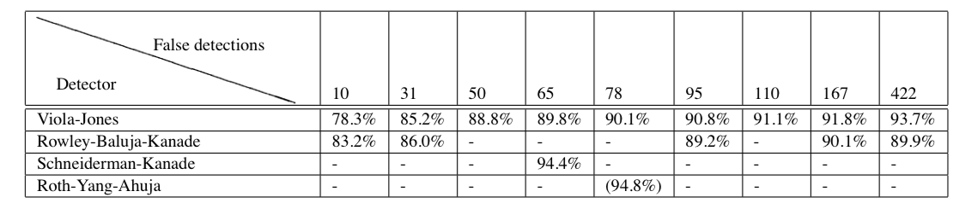

Table 2.7 Various detection rates by different algorithms showing positive and false detection rates [49]

[45] states that” the process of searching a face is called face detection. Face detection is to search for faces with different expressions, sizes and angles in images in possession of complicated light and background and feeds back parameters of face”. In their study, they tested face detection based on two modules which shows one module uses a combination of two algorithms (PCA with SVM) and the other module based on a real-time field-programmable gate array (FPGA). With these they concluded with their results of face detection accuracy of 89%. Table 2.8 is a screen short taken from this paper to show experimental results of two units combined in order to investigate the accuracy of the system.

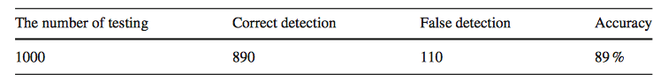

Table 2.8 Detection accuracy system by Wang et al (2015, p.331)

Another method is the **Learning based methods,** that includes machine learning techniques that extract discriminative features from a trained dataset before detection. Some well-known classifiers used for face detection, based on a study by [50] are Canny, Principal Component Analysis (PCA), Support Vector Machine (SVM), and Artificial Neural Network (ANN). Although used for facial expression classification, the algorithms are however, also used in the initial stage of their experiment, which is the detection phase. Their experiment as achieved some results which are shown in Table 2.9. A screenshot from Thai et al. (2011, p.392).

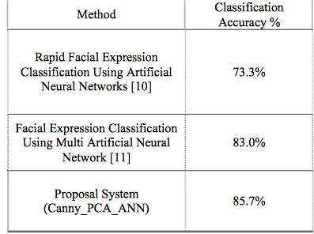

Table 2.9 Comparing Different Algorithms on classification rates [50]

The overall objective of the Face detection part of this project will be to find out if any faces exist in the input image and if present will return the location in bounding boxes and extent of each face, counting the number of faces detected. It is a challenge to this project that due to the variations in location, scale, pose orientation, facial expression, illumination or lighting condition and various appearance features such as facial hair, makeup etc. It will be difficult to achieve an excellent result. However, the performance of the system will be evaluated, taking into consideration the learning time, execution time and number of samples required for training and the ratio between the detection rate and false detections. Table 2.10 below shows experiments from different researchers. They have used different sizes of image dataset. Some have used a combination of different algorithms and applied other methods like color filtering etc. and different training sets to obtain their results. However, we can conclude the Viola-Jones algorithm which is on its own classifies images based on local features only and can still detect at very high accuracy and rapidly than pixel-based systems. [49].

|  |  |  |  |
| --- | --- | --- | --- |
|  | Method | Detection Accuracy | #False Detection |
| Yang et al (2002 pp.36-37) | Knowledge-Based-Method | 83.33% | 28 |
| Ryu et al. (2006) | Image-Based Method | 89.1% | 32 |
| Feraud et al. (2001) | neural network-based | 86.0% | 8 |
| Rowley et al. (1998) | Neural Network-Based | 86.2% | 23 |
| Wang et al. (2016) | CNN-Based | 98.1% |  |
| Hjelmås and Low, (2001, p.240) | Edge Detection-Based | 76% | 30 |
| Viola and Jones (2001). | Viola-Jones | 88.84% | 103 |
| [Wang et al, (2015, p.318)](https://link.springer.com/article/10.1007%2Fs40745-015-0064-6) | PCA with SVM) | 89% | 110 |
| Thai et al. (2011) | Canny_PCA_ANN | 85.7% | N/A |

Table 2.10 Comparison of results by Different Researchers showing face detection accuracy and false detection

### 2.2 Machine Learning

Machine learning is an approach by which machines are trained on data sets in order to improve future performance. The main goal of this discipline is automatic learning paradigm. Machine Learning refers to algorithm update based on past data sets automatically without any human supervision [47].

Using Machine Learning, the programmer develops an approach through which the machine (the algorithm) will come up with its own solution based on the data sets it has been trained on [47].

### 2.2.1 Machine Learning: Intersection of Statistics and Computer Science

Machine Learning is the brain child Computer Science and Statistics. Computer Science in this field focuses on developing machines that solve different problems, and tries to determine weather problems can be solved at all. Statistics employs data inference, modelling hypothesis and measuring reliability of the conclusions. Machine learning concentrates on the task of getting machines to re-program themselves whenever new data are exposed to them through what they have learned from the trained data sets, whereas Computer Science focuses on programming computers manually to solve a particular problem. On the other hand, Statistics concentrate on data probability and analysis, it plays an important role concerning the practicability and effectiveness of machine learning algorithms to process data sets [47].

### 2.2.2 Machine Learning and Human Learning

Yann LeCun proposed that the ability of a machine to learn from data sets is mostly not different from how a human mind learn with time and experience [48]. Although, the concentration on solving machine learning problems by miming how the human brain works did not produce a suitable result. This could be because of the reason that human or animal psychology still remains not fully understood. However, the collaboration between machine learning and human learning is increasing, because human learning is being used as the backbone to explain several machine learning techniques. For example, artificial neural network for building machine learning models are inspired by the brain neural network [48].

### 2.2.3 Data Mining, Artificial Intelligence and Machine Learning

Analytically speaking, these three disciplines are so connected that it is impossible to draw a boundary between them. However, these three disciplines are interdependently related and a collaboration of these disciplines can be used as a strategy to yield more sensitive and efficient outputs. Data mining basically involves the explanation of data, it is the basis for both machine learning and artificial intelligence. Also, it is not only inspection of information from different sources but it analyzes and extract pattern that occur in information that could have been difficult to interpret manually. Data mining is not only to prove a hypothesis but also for drawing appropriate hypothesis. The mined data and its corresponding hypothesis and pattern are used as the basis for both artificial intelligence and machine learning. Artificial intelligence can be referred to as the ability of a machine to solve problems on their own without any supervision from human. Artificial intelligence used data minded to solve problems not by programming the solution into the system. Machine learning takes this paradigm to the next level by providing the data needed for a machine to learn and make successful predictions when exposed to new data [47]. The machine extracts information from the train data sets, and then recognizes hidden patterns using various statistical measures to better its ability to interpret new data and produce much more effective results.

### 2.2.4 Applications

A definite sign of intelligence in Machine Learning is its importance in real-life applications, some of these are explained below [47].

1. **SPEECH RECOGNITION**

One of the applications is speech recognition. All these speech recognition use machine learning paradigms to train the systemfor better speech accuracy.

1. **COMPUTER VISION**

Recently, vision systems, e.g., facial recognition software, which are systems capable of automatically classifying microscopic images of cells; employ machine learning approaches for better accuracy.

1. **ROBOT OR AUTOMATION CONTROL**

Machine Learning methods are used in robot and automated systems. For example, consider the control strategies for stable flight and aerobatics of helicopters can be achieved through machine learning. Google’s self-driving car is a real Machine Learning application.

1. **BIO-SURVEILLANCE**

Tracking possible outbreak of diseases can be achieved by using Machine Learning models. The software system is trained using the profiles of admitted patients in order to detect anomalous symptoms, their patterns and their area and level of distribution. There are still ongoing studies to integrate additional data in the system, like medicines’ purchase history to provide more training data sets [47].

### References

|  |  |
| --- | --- |
| [1] | Gemalto, "Facial recognition in 2020: 7 trends to watch | Gemalto," 11 March 2018. [Online]. Available: https://www.gemalto.com/govt/biometrics/facial-recognition. [Accessed 11 November 2019]. |
| [2] | Shopify, "Ecommerce definition- What is ecommerce?," 15 january 2019. [Online]. Available: https://www.shopify.com/encyclopedia/what-is-ecommerce. [Accessed 11 november 2019]. |
| [3] | Facex.io, "4 Major Applications of Facial Recognition | History | Data Used," 17 August 2019. [Online]. Available: https://facex.io/blog/facial-recognition-applications/. [Accessed 11 November 2019]. |
| [4] | J. Norman, "Woodrow Bledsoe Originates of Automated Facial Recognition," 7 July 2016. [Online]. Available: http://www.historyofinformation.com/detail.php?entryid=2495. [Accessed 11 November 2019]. |
| [5] | A. A. S. Liton Chandra Paul, "Face recognition using principal component analysis method," *International Journal of Advanced Research in Computer Engineering & Technology (IJARCET) ,* vol. 1, no. 9, p. 5, 2012. |
| [6] | M. Lorentzon, "Feature extraction for image selection using machine learning," Linkoping University, Department of Electrical Engineering, Computer Vision, Linkoping, Sweden, 2017. |
| [7] | G. Templeton, "Facial Recognition Technology explained," Globalme, Vancouver, 2018. |
| [8] | A. France-Presse, "Smile-to-pay: Chinese shoppers turn to facial payment technology," The Guardian, 4 September 2019. [Online]. Available: https://www.theguardian.com/world/2019/sep/04/smile-to-pay-chinese-shoppers-turn-to-facial-payment-technology. [Accessed 11 15 November]. |
| [9] | J. Pritchard, "Personal Identification Number (PIN) Security Tips," The Balance, 2 August 2019. [Online]. Available: https://www.thebalance.com/pin-number-definition-and-explanation-315344. [Accessed 18 December 2019]. |
| [10] | Techterms, "Digital Camera," Tecchterms, 13 November 2009. [Online]. Available: https://techterms.com/definition/digitalcamera. [Accessed 21 December 2019]. |
| [11] | X. HongJu, W. FenMei, W. XiuZhen and W. Fei, "Some key problems of data management in army data engineering based on big data," in *2017 IEEE 2nd International Conference on Big Data Analysis (ICBDA)(*, Beijing, 2017. |
| [12] | M. Wall, "Is facial recognition tech really a threat to privacy?," BBC News, June 2015. [Online]. Available: https://www.bbc.com/news/technology-33199275. [Accessed 2 January 2020]. |
| [13] | L. Moon, "China’s Facial Recognition Catches Another Fugitive Jacky Cheung Fan," South China Morning Post, 22 May 2018. [Online]. Available: https://www.scmp.com/news/china/society/article/2147245/chinasfacial-recognition-cameras-apprehend-third-fugitive-jacky. |
| [14] | F. Jenner, "FaceSearch Is the New Facial Recognition Tool Used to Fight Human Trafficking," Techli (blog), 10 July 2018. . [Online]. Available: https://techli.com/facesearch-is-the-new-facial-recognition-tool-used-tofight-human-trafficking/54617/. |
| [15] | A. Lee, "Alipay Rolls out World’s First ‘Smile to Pay’ Application in Hangzhou," South China Morning Post, 1 September 2017. [Online]. Available: https://www.scmp.com/tech/start-ups/article/2109321/alipay-rolls-outworlds-first-smile-pay-facial-recognition-system-kf. |
| [16] | S. Liao, "Facial Recognition Scans Are Expanding to Delta Flights in Atlanta International Airport," The Verge, 20 September 2018. [Online]. Available: https://www.theverge.com/2018/9/20/17884476/facialrecognition-scan-delta-flight-atlanta-international-airport. |
| [17] | S. 2. “. C. S. I. E. w. F. R. t. P. f. F. T. V. M. 1. 2. - Liao. [Online]. Available: https://www.theverge.com/2019/3/13/18263923/chinese-subway-facialrecognition-fares-pay-ai.. |
| [18] | S. Liao, "A Chinese Subway Is Experimenting with Facial Recognition to Pay for Fares," The Verge, 13 March 2019. [Online]. Available: https://www.theverge.com/2019/3/13/18263923/chinese-subway-facialrecognition-fares-pay-ai. |
| [19] | C. X. G. Chen Y N, "A novel identify recognition system based on mobile phone and face recognition," in *Computer Application Software*, Stockholm, Department of Media Technology and Interaction, 2011, pp. 28(3): 77-79. |
| [20] | C. S, "A fast SURF way for human face recognition with cell similarity," in *6th IEEE Conference on Industrial Electronics and Applications*, Southern California, IEEE, 2011, pp. 166-169. |
| [21] | [Online]. Available: https://www.theguardian.com/world/2018/jan/18/china-testing-facial-recognition-surveillance-system-in-xinjiang-report; https://thediplomat.com/2018/04/chinas-ever-expanding-surveillance-state/ ; https://www.nytimes.com/2018/02/03/opinion/sunday/chinasurv. |
| [22] | [Online]. Available: https://www.scmp.com/tech/start-ups/article/2109321/alipay-rolls-out-worlds-first-smile-pay-facial-recognition-system-kfc. |
| [23] | [Online]. Available: https://www.biometricupdate.com/201811/smile-to-pay-facial-recognition-system-now-at-300-locations-in-china. |
| [24] | [Online]. Available: - https://www.bloomberg.com/news/articles/2019-12-11/face-recognition-tech-is-everywhere-at-china-s-new-mega-airport. |
| [25] | S. M. J. F. J. Galbally, "Access," in *Biometric Antispooﬁng Methods: A Survey in Face Recognition*, Rome, IEEE, 2014, p. 1530–1552. |
| [26] | S. M. S. A. M. H. W. A. W. A. .. S. Parveen, "Face anti spooﬁng methods," in *Current Science*, Caulifornia, 2015, pp. 108 (8)1491-1500. |
| [27] | H. H. J. A. Patel K, "Cross-database face antispooﬁng with robust feature representation," in *Chinese Conference on Biometric Recognition* , Beijing, 2016, pp. 611-619. |
| [28] | F. H. B. J. N. Kollreider K, "Intrusive liveness detection by face images," in *Image and Vision Computing* , Beijing, 2009, pp. 27(3) 233-244. |
| [29] | D. T. V. M. S. R. Bharadwaj S, "Face antispooﬁng via motion magniﬁcation and multifeature videolet aggregation," 2014. [Online]. Available: https://repository.iiitd.edu.in/jspui/handle/123456789/138. |
| [30] | S. S. H. J. Kim W, "Face liveness detection from a single image via diffusion speed model.," in *IEEE Transactions on Image Processing* , 2015, pp. 24(8): 2456-2465. |
| [31] | P. L. L. Y. X. X. Y. F. C. T. C. K. Feng L, "Integration of image quality and motion cues for face anti-spooﬁng: A neural network approach.," in *Journal of Visual Communication and Image Representation* , 2016, pp. 38: 451-460. |
| [32] | L. S. D. W. Xu Z, "Learning temporal features using LSTMCNN architecture for face anti-spooﬁng.," in *3rd IEEE Asian Conference on Pattern Recognition (ACPR)*, 2015, pp. 141-145. |
| [33] | H. A. P. M. A. A. M. S. Komulainen J, "Complementary countermeasures for detecting scenic face spooﬁng attacks.," in *6th IEEE International Conference on Biometrics (ICB)* , 2013, pp. 1-7.. |
| [34] | S.-H. Lin, "An Introduction to Face Recognition Technology," in *Informing Science the International Journal of an Emerging Transdiscipline*, 2000, pp. 3 (1) 1-7.. |
| [35] | M. D. O. H. D. a. L. J. Castrillón, "A comparison of face and facial feature detectors based on the Viola–Jones general object detection framework," in *Machine Vision and Applications*, 2011, pp. 22 (3),481-494. . |
| [36] | M. Yang, D. Kriegman and N. Ahuja, "Detecting faces in images," in *A survey IEEE Trans. Pattern Anal. Mach. Intell.* , 2002, pp. 24, 34–58.. |
| [37] | E. a. L. B. K. Hjelmås, "Face Detection: A Survey," in *Computer Vision and Image Understanding*, 2001, pp. 83 (3), 236-274.. |
| [38] | H. C. S. S. a. S. S. Ryu, "Multiple classifiers approach for computational efficiency in multi-scale search based face detection," in *Advances in Natural Computation*, 2006, pp. Pt 1, 4221,483-492.. |
| [39] | R. F. Article, "Raphael Feraud Article," in *IEEE Transactions on Pattern Analysis and Machine Intelligence*, 2001. |
| [40] | D. W. Article, "IEEE Transactions on Pattern Analysis and Machine Intelligence," *IEEE transaction,* pp. 39(6):1-1, 2017. |
| [41] | M. a. M. F. Modi, "Face Detection Approaches," in *A Survey.', International Journal of Innovative Research in Science, Engineering and Technology*, 2014, pp. 3 (4),11107-11116. |
| [42] | N. a. Padmavathi, "Facial parts detection using Viola Jones algorithm 4th International Conference," in *Advanced Computing and Communication Systems (ICACCS)*, 2017. |
| [43] | M. S. (. '. &. A. o. D. F. D. T. (. I. J. o. C. S. a. I. T. Mayank Chauhan, pp. 5 (2), 1615-1618. |
| [44] | M. S. Mayank Chauhan, "Study & Analysis of Different Face Detection Techniques," in *International Journal of Computer Science and Information Technologies*, 2014, pp. 5 (2), 1615-1618. |
| [45] | P. a. J. M. Viola, "Rapid object detection using a boosted cascade of simple features," in *Proceedings of the IEEE Computer Society Conference on Computer Vision and Pattern Recognition*, 2001, pp. I511-I518.. |
| [46] | Y. Y. M. R. M. a. W. L. Taigman, "DeepFace: Closing the gap to human-level performance in face verification," in *Proceedings of the IEEE Computer Society Conference on Computer Vision and Pattern Recognition*, 2014, pp. 1701-1708. |
| [47] | K. Das and R. N. Behera, "A Survey on Machine Learning: Concepts, Algorithms and Applications," *International Journal of Innovative Research in Computer and Communication Engineering,* vol. 5, no. 2, 2017. |
| [48] | Lecun and Bengio, Convolutionl Networks for Images, Speech, and Time series, Beijng, 1995. |